# Spring Certification Module 6 -Spring Security

# Question 01 -What are authentication and authorization? Which must come first?

## 1.1 Authentication

**Authentication** is a process of verifying that user, device or external system is who he/she/it claims to be. It involves validation that submitted proof of identity is true.

In other words, authentication answers question “Who are you?”, and checks if provided answer is valid.

Process usually involves one side sending Identity and Credential that is used to validate that Identity statement is true, and other side that checks Credential and accepts or rejects claimed Identity based on Credential.



Authentication may take different forms, simplest one uses username as Identity and password as credential –proof of identity.

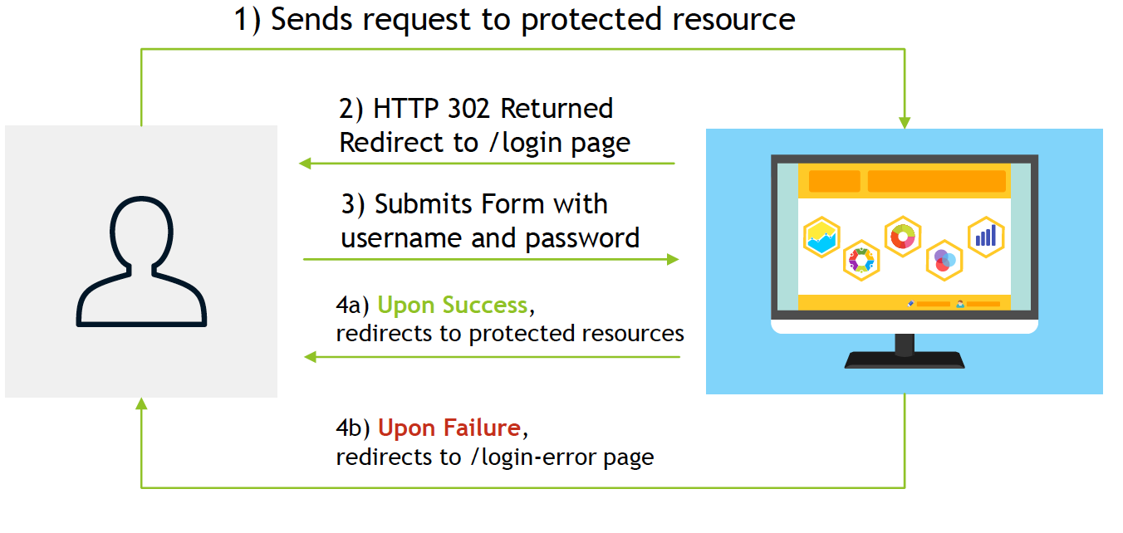

More sophisticated forms of authentication, may involve three parties for implementation of Central Authentication Service (CAS) to allow single sign-on.

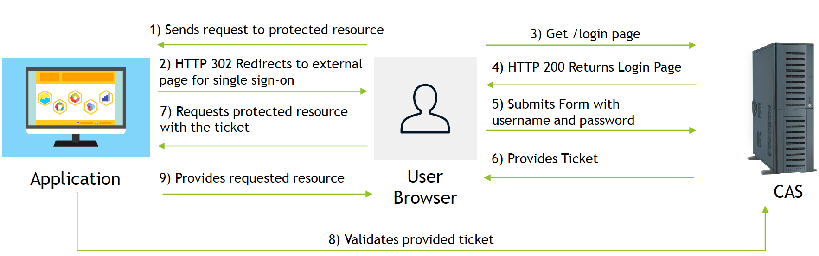

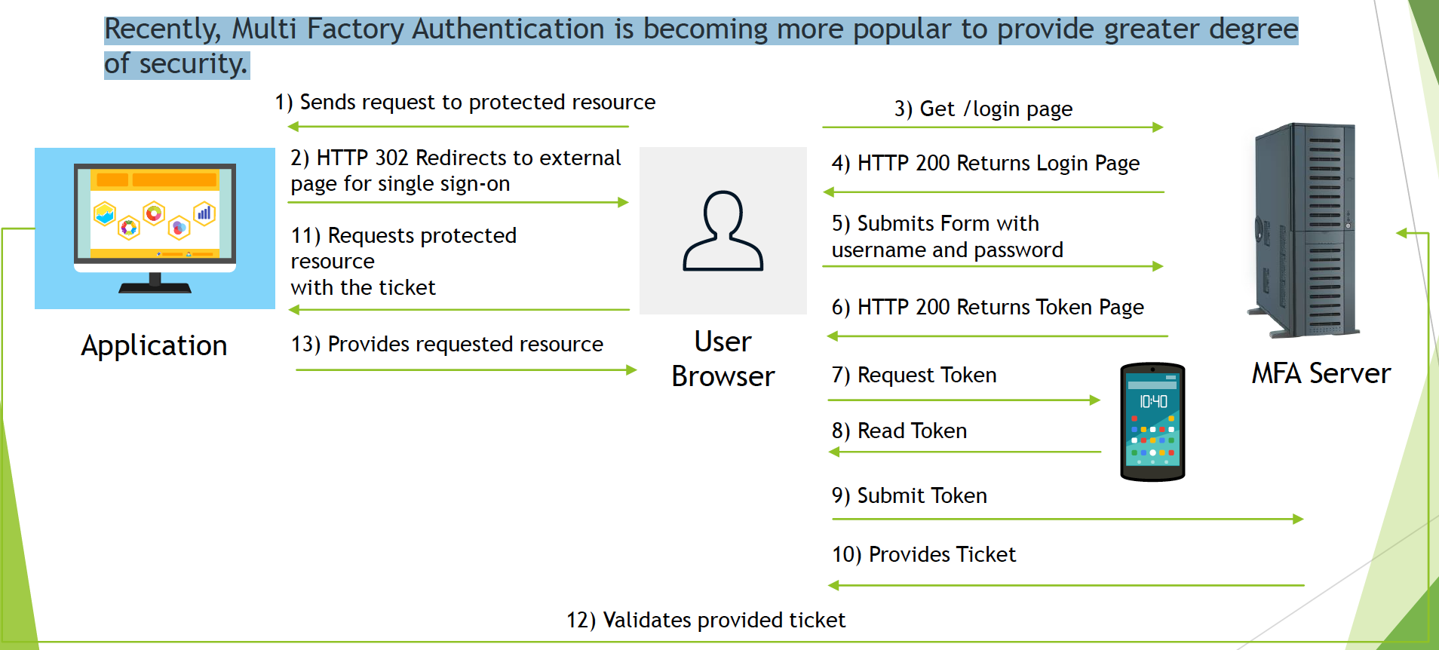

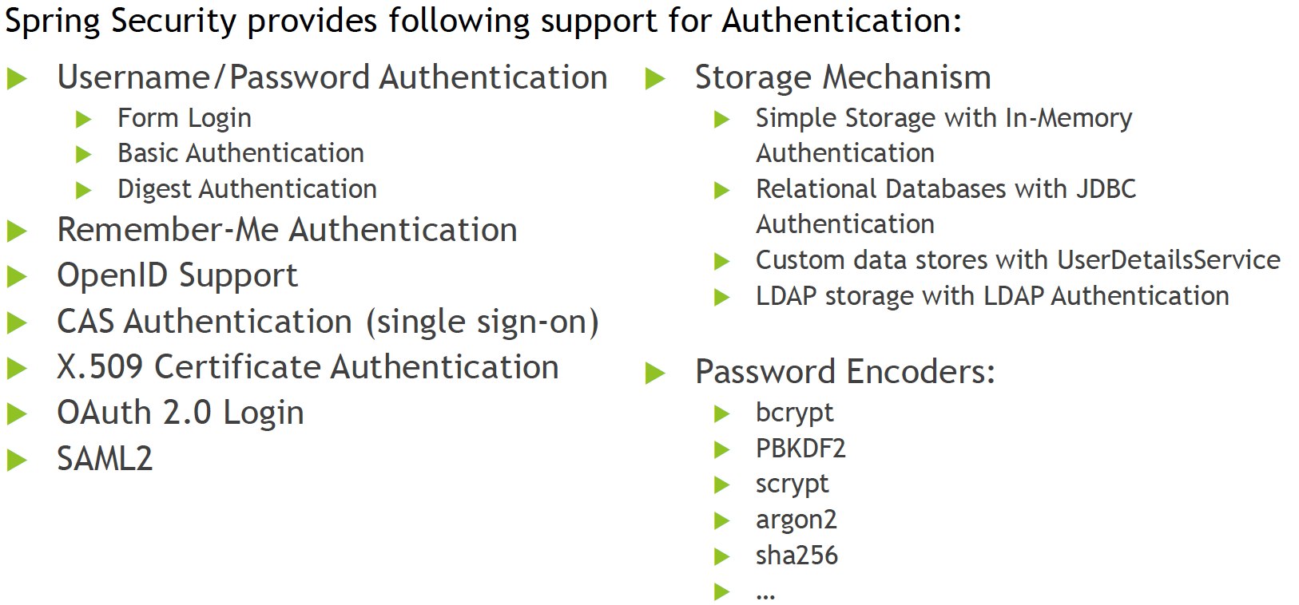

## 1.2 Authorization

**Authorization** is a process of determining whether an authenticated user is allowed to access certain resources within the system or allowed to perform a certain action within the application.

In other words, authorization answers question “What are you allowed to do?”.

Authorization usually uses formalized policy specified as access control rules, to determine allowed and disallowed parts of the system that authenticated user can visit and act upon.

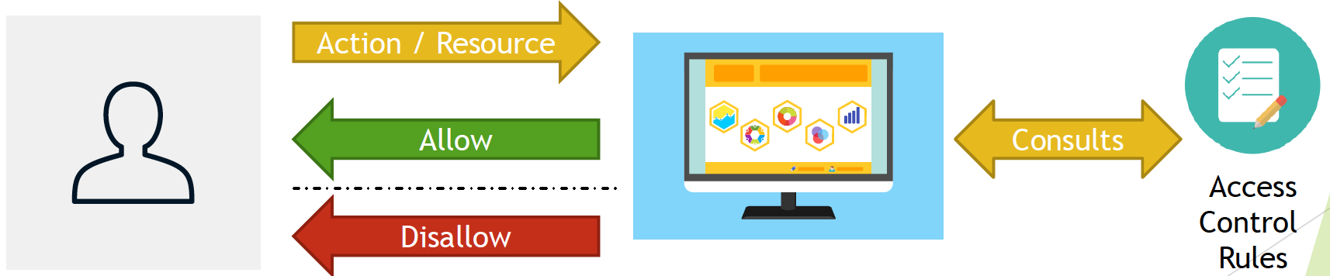

Spring Security allows you to implement **authorization** within your application on two levels:

* Web Security Level with usage of Expression
* mvcMatchers("/admin/**").hasRole("ADMIN")
* Method Security Level with usage of:
* @Secured annotation
* @PreAuthorize annotation
* JSR 250 annotations
* @RolesAllowed
* @PermitAll
* @DenyAll
* ...

Access Control Rules can be expressed via:

* Roles
  + Represents a high-level set of privileges, for example ROLE_ADMIN, ROLE_STAFF, ROLE_CUSOMERSetc.
  + Used with expressions like hasRole
* Authorities
  + Represents a low-level, granular privilege/authority in the system for example READ_CUSTOMERS, DELETE_EMPLOYEE, ACCESS_APIetc.
  + Used with expressions like hasAuthority
* Hierarchical Roles
  + Allows you to specify relationships between roles and express that one role includes all permissions granted to other role
  + Example:
    - ROLE_ADMIN > ROLE_STAFF -ROLE_ADMINincludes ROLE_STAFF

**Authentication** needs to be executed first, before **authorization**, because for authorization process to know which roles/authorities can be granted for particular user, system needs to be sure that user is who he/she claims to be.



## 1.3 Controllers

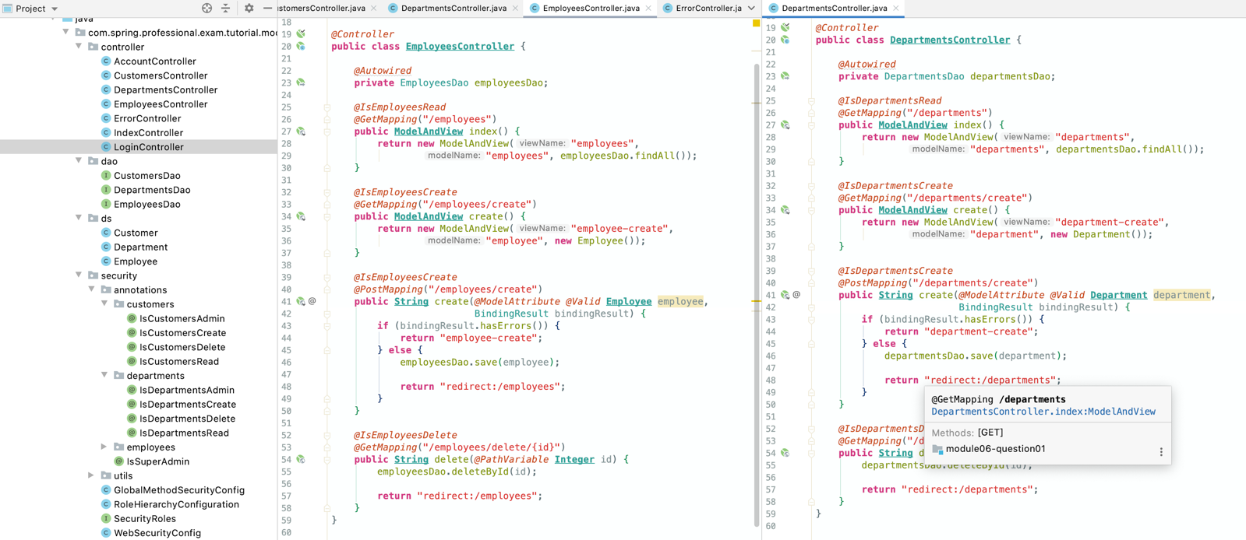

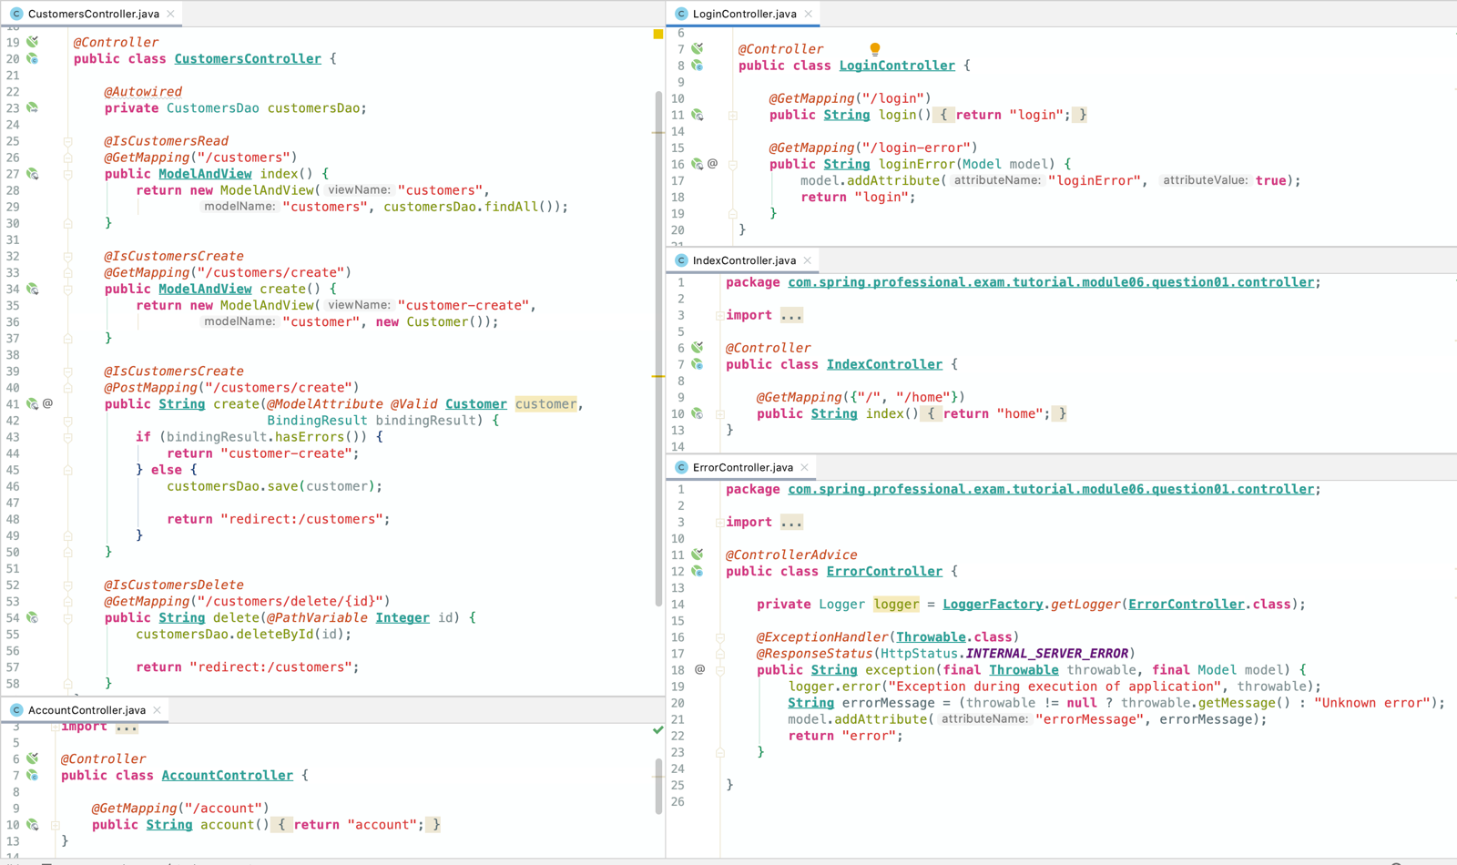

## 1.4 DAOs

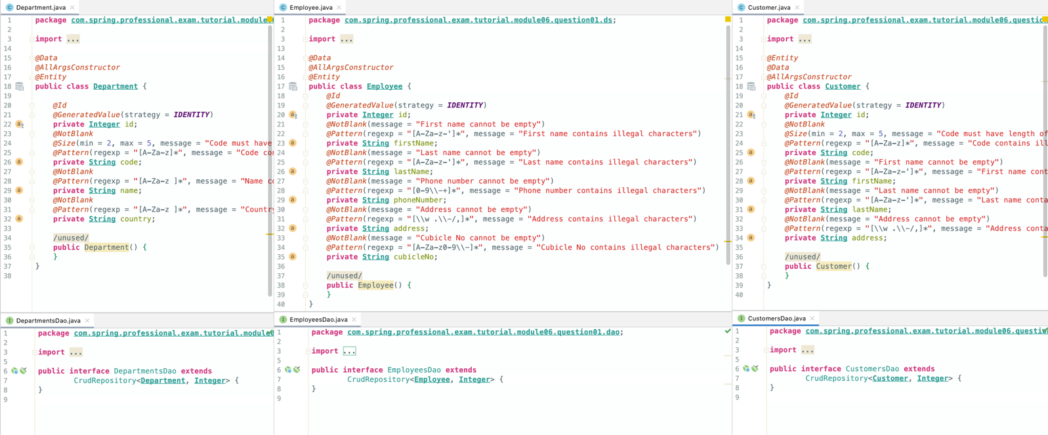

## 1.5 Annotations

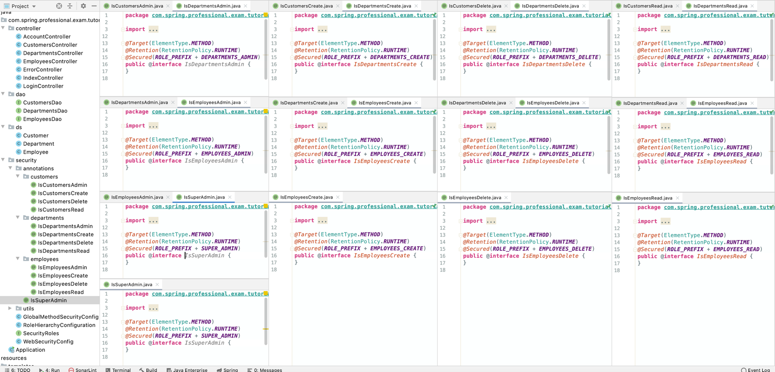

## 1.6 Security

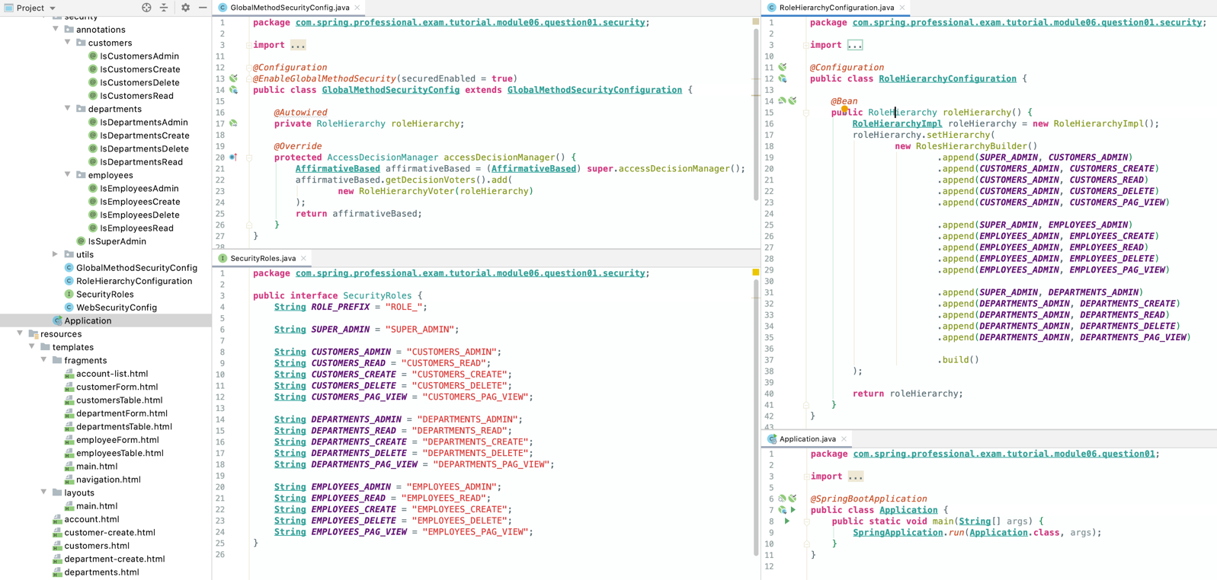

*@Configuration  
@EnableWebSecurity***public class WebSecurityConfig extends WebSecurityConfigurerAdapter** {  
  
 *@Autowired* **private** RoleHierarchy roleHierarchy;  
  
 *@Override* **protected void** configure(**HttpSecurity** http) **throws Exception** *{* http  
 .authorizeRequests()  
 .expressionHandler(expressionHandler())  
 .mvcMatchers("/", "/home").permitAll()  
 .mvcMatchers("/employees").hasRole(***EMPLOYEES_PAG_VIEW***)  
 .mvcMatchers("/departments").hasRole(***DEPARTMENTS_PAG_VIEW***)  
 .mvcMatchers("/customers").hasRole(***CUSTOMERS_PAG_VIEW***)  
 .anyRequest().authenticated()  
 .and()  
 .formLogin()  
 .loginPage("/login")  
 .failureUrl("/login-error")  
 .permitAll()  
 .and()  
 .logout()  
 .logoutUrl("/logout")  
 .logoutSuccessUrl("/login")  
 .permitAll();  
 *}  
  
 @Override* **protected void** configure(**AuthenticationManagerBuilder** auth) **throws Exception** *{* PasswordEncoder encoder = **PasswordEncoderFactories**.*createDelegatingPasswordEncoder*();  
  
 auth.inMemoryAuthentication()  
 .withUser("john")  
 .password(encoder.encode*(*"john"*)*)  
 .roles(***SUPER_ADMIN***)  
 .and()  
 .withUser("emma")  
 .password(encoder.encode*(*"emma"*)*)  
 .roles(***EMPLOYEES_ADMIN***)  
 .and()  
 .withUser("william")  
 .password(encoder.encode*(*"william"*)*)  
 .roles(***DEPARTMENTS_PAG_VIEW***, ***DEPARTMENTS_READ***, ***DEPARTMENTS_CREATE***)  
 .and()  
 .withUser("lucas")  
 .password(encoder.encode*(*"lucas"*)*)  
 .roles(***CUSTOMERS_PAG_VIEW***, ***CUSTOMERS_READ***)  
 .and()  
 .withUser("tom")  
 .password(encoder.encode*(*"tom"*)*)  
 .roles();  
 *}* **private DefaultWebSecurityExpressionHandler** expressionHandler() *{* **DefaultWebSecurityExpressionHandler** expressionHandler = **new** DefaultWebSecurityExpressionHandler();  
 expressionHandler.setRoleHierarchy(roleHierarchy);  
 **return** expressionHandler;  
 *}*}

# Question 02-Is security a cross cutting concern? How is it implemented internally?

Yes, Security is a cross cutting concern.

Cross cutting concern –functionality of a program not immediately associated with the business logic, applicable throughout the application and affecting multiple parts of the system.

Security fits well into above definition, other examples of cross cutting concerns include functionalities like logging or transactions.

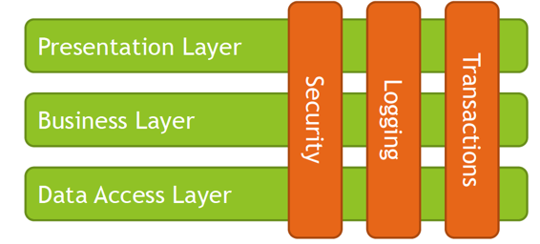

Security in Spring is implemented on two levels:

* Web Level –based on Servlet Filters
* Method Security Level –based on Spring AOP

Each aspect of Security –Authentication and Authorization is handled on both of those levels with different set of components:

* Authenthicaton
  + AuthenticationManager
  + ProviderManager
  + AuthenticationProvider
  + UserDetailsService
* Authorization
  + AccessDecisionManager
  + AccessDecisionVoter
  + AfterInvocationManager
  + Authorities

Web Level Spring Security uses Servlet Filters to analyze each request made to the system, and based on rules specified through WebSecurityConfigurerAdapter and HttpSecurity object, performs certain decision against authentication or authorization. Such decision may include redirecting request to login page, or rejecting request because of roles not being assigned to the user.

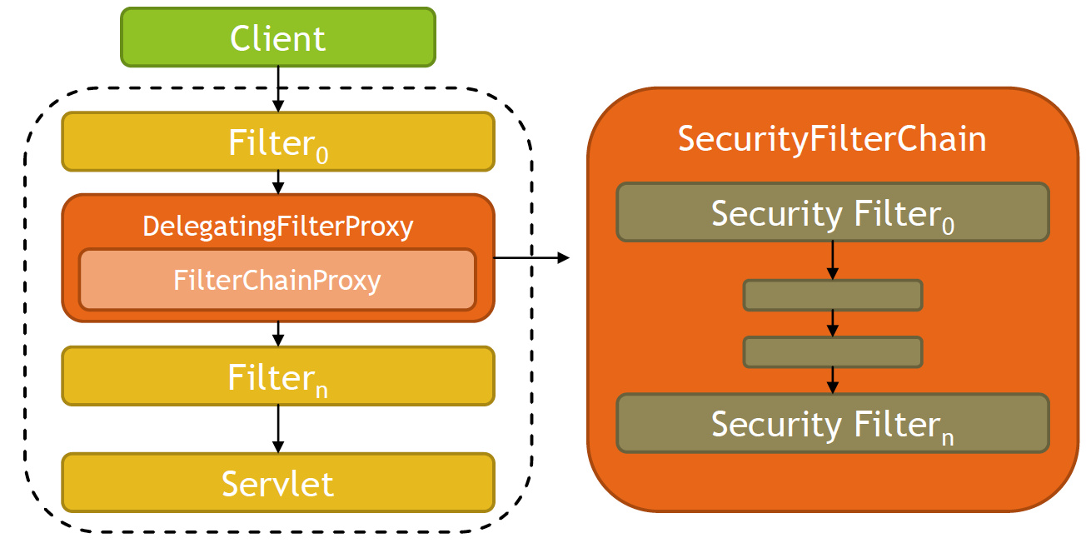

Method Security Level uses Spring AOP to proxy invocations to objects, applied advices ensures that during invocation, security rules are met to allow invocation, for example user needs to contain set of roles/authorities to execute method.

To enable method level security you need to use @EnableGlobalMethodSecurity annotation and enable support to one of annotation types:

* prePostEnabled-Security's pre post annotations -@PreAuthorize
* securedEnabled-@Secured annotation -Spring Security's @Secured annotations
* jsr250Enabled–JSR 250 annotations @RolesAllowed, @PermitAll, @DenyAll, ...

Spring Security uses many objects to implement security:

* SecurityContextHolder–heart of Spring Security authentication model, place were Spring stores the details of who is authenticated
* SecurityContext–held by SecurityContextHolder, gives access to Authentication object
* Authentication object–used as input to AuthenticationManager to provide the credentials that user has provided to authenticate, also represents the currently authenticated user, contains principal, credentials, authorities
* GrantedAuthority-high level permissions the user is granted, for example roles, ROLE_ADMIN, ROLE_EDITOR, ROLE_VIEWER etc.
* AuthenticationManager-API that defines how Spring Security’s Filters perform authentication, usually implemented by ProviderManager
* ProviderManager–is an AuthenticationManager that delegates to list of AuthenticationProviders, if at least AuthenticationProvider will successfully authenticate user, user is logged into the system

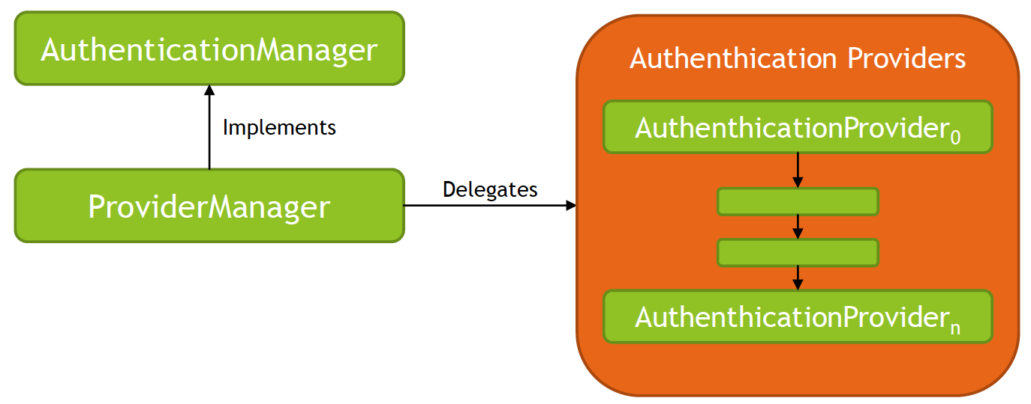

* AccessDecisionManager–called by SecurityInterceptors before executing method/action, used for authorization to check if user is allowed to perform certain action or access certain resource in the system based on GrantedAuthority objects

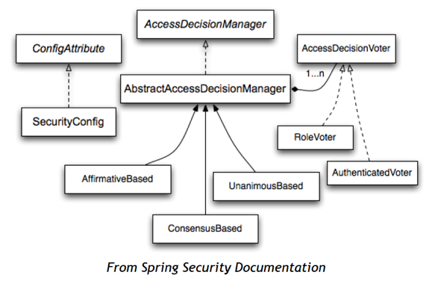

* AfterInvocationManager–called after executing method/action, used for authorization to ensure the principal is permitted to access the domain object instance returned by a service layer bean

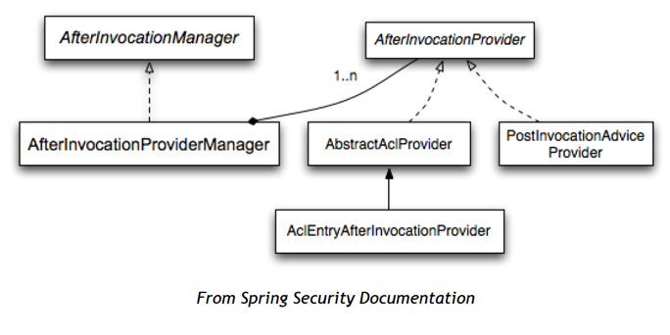

Spring Security is able to access list of users and authorities based on UserDetailsServiceabstraction, following storage types are supported:

* Simple Storage with In Memory Authentication
* Relational Databases with JDBC Authentication
* Custom data stores with UserDetailsService
* LDAP storage with LDAP Authentication

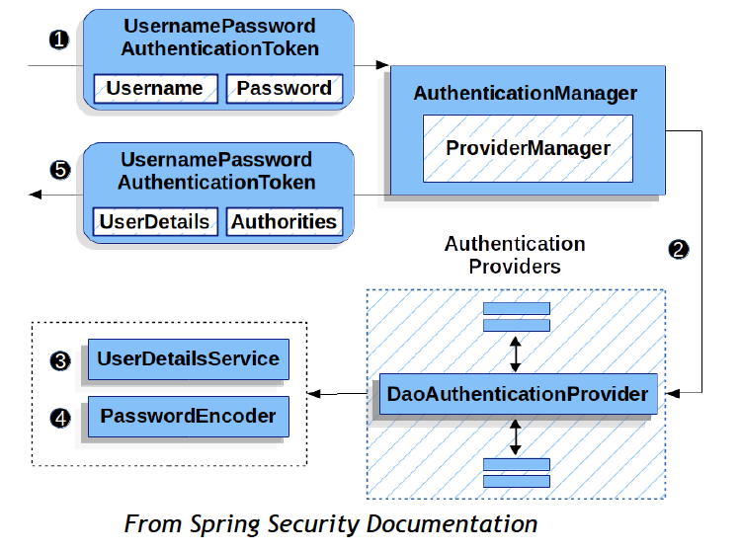

Here is an example scenario that Spring Security can handle with usage of Authenthiation and Authorization components:

1. User tries to access protected resource.
2. Application requires the user to provide username and password(form login). Username is identifier, password is credential.
3. Credentials are verified by the AuthenticationManager, implemented by ProviderManager, which delegates to AuthenthicationProviders, user is granted access to the application, SecurityContext will hold authorization rights for this user.
4. User tries to edit some resource, which is implemented by method on controller level, SecurityInterceptor intercepts the request.
5. SecurityInterceptorextracts the user authorization data from the SecurityContext.
6. AccessDecisionManageris invoked to check if user is allowed to perform requested operation.
7. AccessDecisionManagerdelegates call to a list of AccessDecisionVoters to check if user is allowed to perform requested operation.
8. Access is granted or denied.

Example is the same as in Question 1. Use break points in the following classes to check app:

*// Spring Security Code Places to analyze:  
// DelegatingFilterProxy.doFilter  
// FilterChainProxy.doFilterInternal  
// ProviderManager.authenticate  
// AffirmativeBased.decide  
// RoleVoter.vote*

# Question 03-What is the delegating filter proxy?

DelegatingFilterProxy is an internal Spring Framework class located in package org.springframework.web.filter of spring-web module.

This class acts as a Proxy between standard Servlet Filter and Spring-managed Bean that implements Servlet Filter. DelegatingFilterProxy is registered within application container and delegates all calls to Bean registered within Spring Application Context.

We may say that it acts like a bridge between Servlet Container and Spring Application Context.

Bean to which all calls should be delegated to is located based on Filter Name provided within Filter Configuration, usually it is named springSecurityFilterChain and is an instance of FilterChainProxy.

DelegatingFilterProxy can be registered in following ways:

* Servlet 3 –via AbstractSecurityWebApplicationInitializer
  + Method insertSpringSecurityFilterChain will register DelegatingFilterProxy
  + *@ComponentScan*("com.spring.professional.exam.tutorial.module06.question03")  
    **public class ApplicationInitializer extends AbstractSecurityWebApplicationInitializer** {  
      
     *@Override* **protected void** beforeSpringSecurityFilterChain(ServletContext servletContext) *{* **AnnotationConfigWebApplicationContext** context = **new** AnnotationConfigWebApplicationContext();  
      
     context.setServletContext(servletContext);  
     context.register(**ApplicationInitializer**.**class**);  
     context.refresh();  
      
     ServletRegistration.Dynamic dispatcher = servletContext  
     .addServlet("dispatcher", **new** DispatcherServlet*(*context*)*);  
      
     dispatcher.setLoadOnStartup(1);  
     dispatcher.addMapping("/*");  
     *}*}
* Servlet 2 –via web.xml
  + *<***filter***>  
     <***filter-name***>*springSecurityFilterChain*</***filter-name***>  
     <***filter-class***>*org.springframework.web.filter.DelegatingFilterProxy*</***filter-class***>  
    </***filter***>  
    <***filter-mapping***>  
     <***filter-name***>*springSecurityFilterChain*</***filter-name***>  
     <***url-pattern***>*/\**</***url-pattern***>  
    </***filter-mapping***>*
  + springSecurityFilterChain is a default name for FilterChainProxy specified in AbstractSecurityWebApplicationInitializer#DEFAULT_FILTER_NAME
* Spring Boot
  + uses DelegatingFilterProxyRegistrationBean instead of regular DelegatingFilterProxy to create specialized version of DelegatingFilterProxy
  + Registered by SecurityFilterAutoConfiguration

Role of DelegatingFilterProxy is to delegate all calls to FilterChainProxy, which contains SecurityFilterChain responsible for Web Level authentication and authorization:

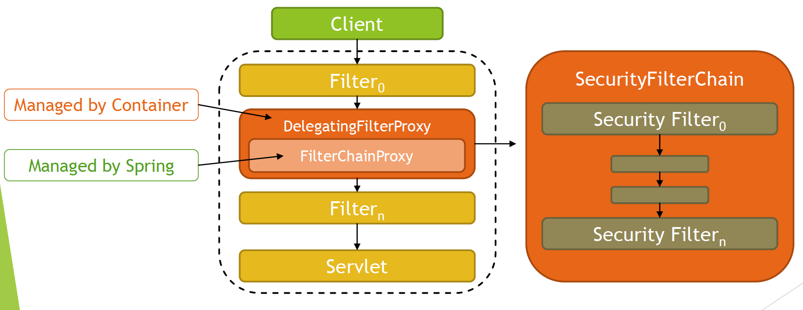

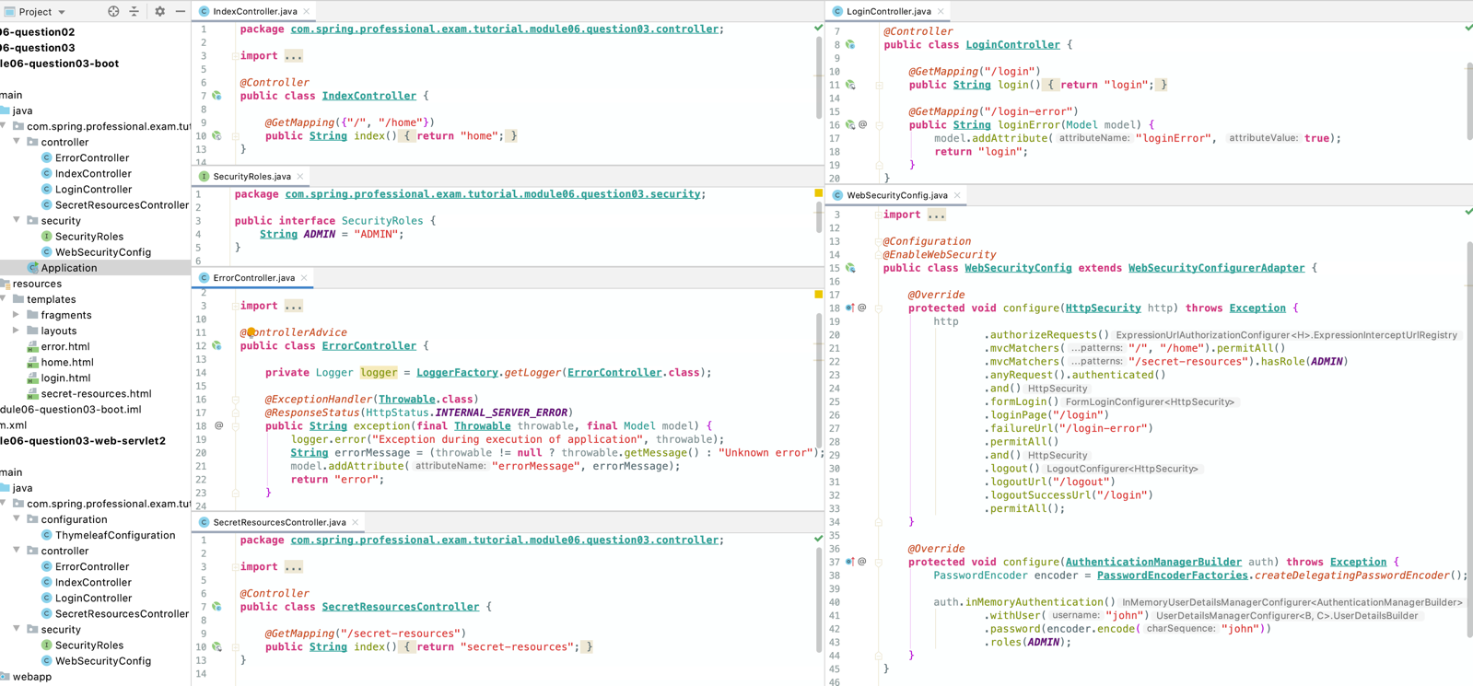

Springboot example above

# Question 04 -What is the security filter chain?

Security Filter Chain is a collection of Spring Managed Filters that are responsible for authentication and authorization. Usually they include functionalities like Username & Password Authentication, Logout Management, Session Management, Security Interceptors etc.

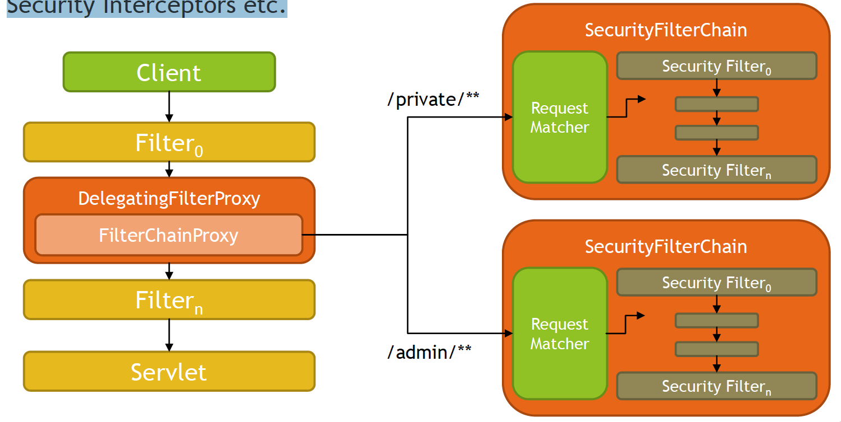

SecurityFilterChain is an interface located in package org.springframework.security.web of spring-web module.

This interface specifies a contract for behaviour that associates request URL to list of security filters.

Spring provides one implementation of this interface called DefaultSecurityFilterChain which uses request matchers to check if list of security filters should be applied to specified url.

Some of the request matchers that can be used include AntPathRequestMatcher, MvcRequestMatcher, RequestHeaderRequestMatcher, MediaTypeRequestMatcher etc.

Security Filters are implementation of Servlet Filter and are usually managed by Spring Context.

FilterChainProxy holds list of SecurityFilterChains and upon request searches for the first SecurityFilterChainthat matches request.

Upon request being matched, SecurityFilterChainis picked up and list of Filters is being fetched from SecurityFilterChain.

After that FilterChainProxy executes Filters from SecurityFilterChain.

FilterChainProxy is a registered bean in Spring Context and takes default name specified inside AbstractSecurityWebApplicationInitializer#DEFAULT_FILTER_NAME which is springSecurityFilterChain.

FilterChainProxy is fetched from the context based on name within DelegatingFilterProxy.

Spring usually includes following Filters within Security Filter Chains:

* WebAsyncManagerIntegrationFilter
* SecurityContextPersistenceFilter
* HeaderWriterFilter
* CsrfFilter
* LogoutFilter
* UsernamePasswordAuthenticationFilter
* RequestCacheAwareFilter
* SecurityContextHolderAwareRequestFilter
* AnonymousAuthenticationFilter
* SessionManagementFilter
* ExceptionTranslationFilter
* FilterSecurityInterceptor

Spring provides API to customize list of used Security Filters, by extending WebSecurityConfigurerAdapter and overriding configure method.

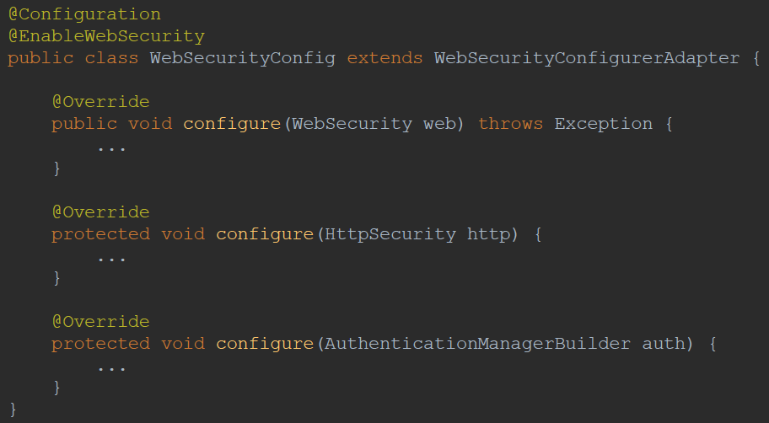

*@Configuration  
@EnableWebSecurity***public class WebSecurityConfig extends WebSecurityConfigurerAdapter** {  
  
 *@Autowired* **private** RoleHierarchy roleHierarchy;  
  
 *@Override* **protected void** configure(**HttpSecurity** http) **throws Exception** *{* http  
 .addFilterBefore(**new** CustomRequestParameterAuthenticationFilter(), **LogoutFilter**.**class**)  
 .authorizeRequests()  
 .expressionHandler(expressionHandler())  
 .mvcMatchers("/", "/home").permitAll()  
 .mvcMatchers("/employees").hasRole(***EMPLOYEES_PAG_VIEW***)  
 .mvcMatchers("/departments").hasRole(***DEPARTMENTS_PAG_VIEW***)  
 .mvcMatchers("/customers").hasRole(***CUSTOMERS_PAG_VIEW***)  
 .anyRequest().authenticated()  
 .and()  
 .formLogin()  
 .loginPage("/login")  
 .failureUrl("/login-error")  
 .permitAll()  
 .and()  
 .logout()  
 .logoutUrl("/logout")  
 .logoutSuccessUrl("/login")  
 .permitAll();  
 *}  
  
 @Override* **protected void** configure(**AuthenticationManagerBuilder** auth) **throws Exception** *{* PasswordEncoder encoder = **PasswordEncoderFactories**.*createDelegatingPasswordEncoder*();  
  
 auth.inMemoryAuthentication()  
 .withUser("john")  
 .password(encoder.encode*(*"john"*)*)  
 .roles(***SUPER_ADMIN***)  
 .and()  
 .withUser("emma")  
 .password(encoder.encode*(*"emma"*)*)  
 .roles(***EMPLOYEES_PAG_VIEW***)  
 .and()  
 .withUser("william")  
 .password(encoder.encode*(*"william"*)*)  
 .roles(***DEPARTMENTS_PAG_VIEW***)  
 .and()  
 .withUser("lucas")  
 .password(encoder.encode*(*"lucas"*)*)  
 .roles(***CUSTOMERS_PAG_VIEW***)  
 .and()  
 .withUser("tom")  
 .password(encoder.encode*(*"tom"*)*)  
 .roles();  
 *}* **private DefaultWebSecurityExpressionHandler** expressionHandler() *{* **DefaultWebSecurityExpressionHandler** expressionHandler = **new** DefaultWebSecurityExpressionHandler();  
 expressionHandler.setRoleHierarchy(roleHierarchy);  
 **return** expressionHandler;  
 *}*}

*/ will authenticate based on request parameter  
// http://localhost:8080/employees?X-AUTH-TOKEN=SECRET_AUTH_TOKEN_ADMIN - can bypass security login with this***public class CustomRequestParameterAuthenticationFilter extends GenericFilterBean** {  
  
 **public static final String *SECRET_AUTH_TOKEN_ADMIN*** = "SECRET_AUTH_TOKEN_ADMIN";  
  
 *@Override* **public void** doFilter(ServletRequest request, ServletResponse response, FilterChain chain) **throws IOException**, **ServletException** *{* SecurityContext securityContext = **SecurityContextHolder**.*getContext*();  
  
 **if** (***SECRET_AUTH_TOKEN_ADMIN***.equals*(*request.getParameter*(*"X-AUTH-TOKEN"*))* && securityContext != **null**) *{* securityContext.setAuthentication*(* **new** AnonymousAuthenticationToken*(* "x-auth", "X-ADMIN",  
 **Collections**.*singletonList(* **new** SimpleGrantedAuthority*(*SecurityRoles.***ROLE_PREFIX*** + SecurityRoles.***SUPER_ADMIN****)  
 )  
 )  
 )*;  
 *}* chain.doFilter(request, response);  
 *}*}

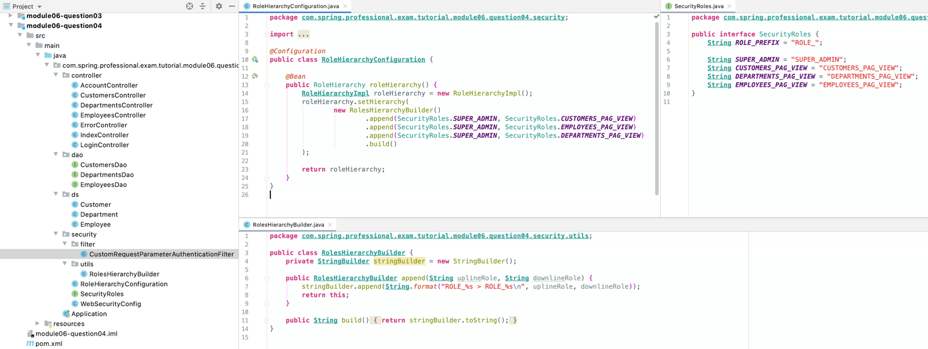

# Question 05-What is a security context?

SecurityContext is an interface, allowing you to access security information associated with the current thread of execution. Interface provides two methods:

* getAuthentication-provides currently authenticated principal, or an authentication request token
* setAuthentication-sets currently authenticated principal, or removes the authentication

SecurityContext can be accessed via SecurityContextHolder, which allows access in three modes:

* MODE_THREADLOCAL
* MODE_INHERITABLETHREADLOCAL
* MODE_GLOBAL

SecurityContextHolder is set to MODE_THREADLOCAL by default, it allows each Thread to access it’s own dedicated SecurityContext.

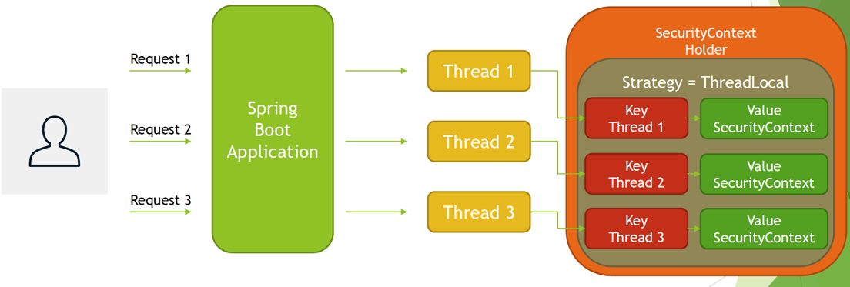

When SecurityContextHolder is set to MODE_INHERITABLETHREADLOCAL, then child threads are allowed to access same SecurityContext as parent Thread.

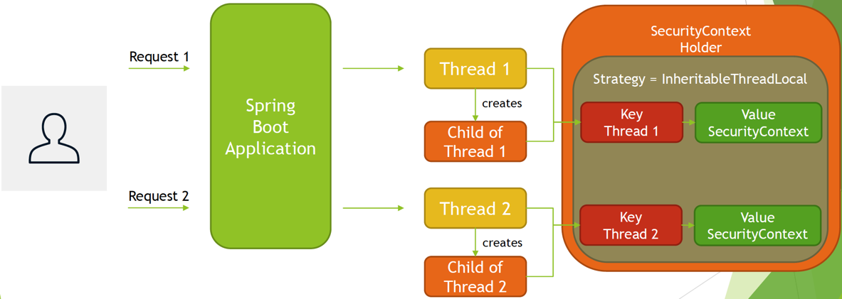

When SecurityContextHolder is set to MODE_GLOBAL, then all threads within JVM are accessing same SecurityContext, this mode is usually used by standalone desktop applications, such as Java Swing based clients.

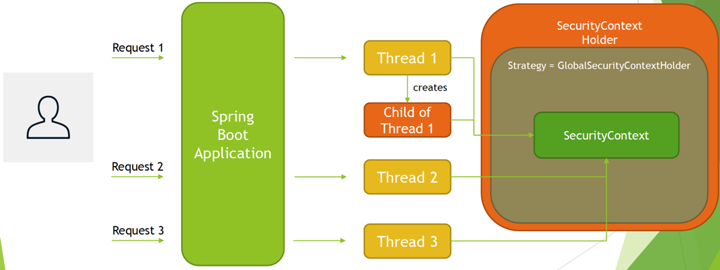

Mode of SecurityContextHolder can be changed via:

* Property -spring.security.strategy
* Programmatically -SecurityContextHolder#setStrategyName

Allowed values are:

* MODE_THREADLOCAL(default)
* MODE_INHERITABLETHREADLOCAL
* MODE_GLOBAL

SecurityContext allows you to access or set currently used Authentication object.

Authentication object represents the token for an authentication request or an authenticated principal, once the authentication request has been processed. Authentication object contains following methods:

* getPrincipal-identity of the principal being authenticated
* getAuthorities–collection of authorities granted to the principal
* getCredentials-credentials that prove the principal is correct
* getDetails-additional details about the authentication request, address, certificate, serial number etc.
* isAuthenticated, setAuthenticated–for internal use by AbstractSecurityInterceptor, AuthenticationManagerto control required amount of for re-authentications

*@Controller***public class AccountController** {  
  
 **private static final String *MAIN*** = "main";  
 **private static final String *CHILD*** = "child";  
  
 *@GetMapping*("/account")  
 **public String** account(Model model) **throws InterruptedException** *{  
 //uncomment to test MODE_GLOBAL  
 //TimeUnit.SECONDS.sleep(3);* model.addAttribute("securityContextHolderStrategy", **SecurityContextHolder**.*getContextHolderStrategy*().getClass().getSimpleName());  
  
 storeSecurityContextDataInModelInMainThread(model);  
 storeSecurityContextDataInModelInChildThread(model);  
  
 **return** "account";  
 *}* **private void** storeSecurityContextDataInModelInMainThread(Model model) *{* storeSecurityContextDataInModel(***MAIN***, model);  
 *}* **private void** storeSecurityContextDataInModelInChildThread(Model model) **throws InterruptedException** *{* **Thread** thread = **new** Thread(() -> storeSecurityContextDataInModel*(****CHILD***, model*)*);  
 thread.start();  
 thread.join();  
 *}* **private void** storeSecurityContextDataInModel(**String** prefix, Model model) *{* SecurityContext securityContext = **SecurityContextHolder**.*getContext*();  
 Authentication authentication = securityContext.getAuthentication();  
 **User** user = (**User**) **Optional**.*ofNullable(*authentication*)* .map*(*Authentication::getPrincipal*)* .orElse*(***null***)*;  
  
 model.addAttribute(prefix + "HashCode", **Integer**.*toHexString(*securityContext.hashCode()*)*);  
  
 model.addAttribute(  
 prefix + "Name",  
 **Optional**.*ofNullable(*authentication*)* .map*(*Authentication::getName*)* .orElse*(*"N/A"*)* );  
  
 model.addAttribute(  
 prefix + "Username",  
 **Optional**.*ofNullable(*user*)* .map*(***User**::getUsername*)* .orElse*(*"N/A"*)* );  
  
 model.addAttribute(  
 prefix + "Authorities",  
 **Optional**.*ofNullable(*authentication*)* .map*(*Authentication::getAuthorities*)* .orElse*(***null***)* );  
 *}*}

application.properties

**spring.security.strategy**=MODE_THREADLOCAL  
*#spring.security.strategy=MODE_INHERITABLETHREADLOCAL  
#spring.security.strategy=MODE_GLOBAL*

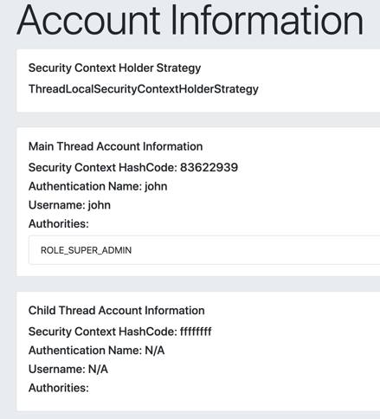

*#spring.security.strategy=MODE_THREADLOCAL***spring.security.strategy**=MODE_INHERITABLETHREADLOCAL  
*#spring.security.strategy=MODE_GLOBAL*

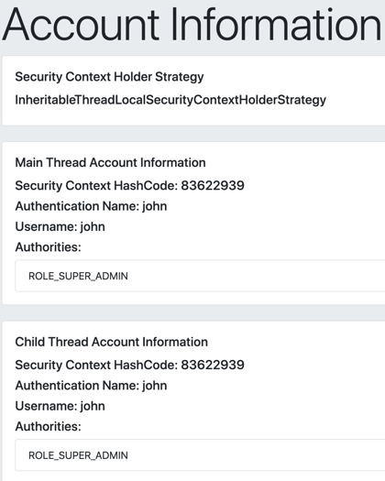

# Question 06-What does the ** pattern in an antMatcheror mvcMatcherdo?

** pattern in antMatcherand mvcMatcher matches zero or more path segments until the end of the path.

antMatcherand mvcMatchersupport following rules:

* ?-matches one character
* *-matches zero or more characters within a path segment
* **-matches zero or more path segments until the end of the path
* Regexps are supported for Path Variables
  + {spring:[a-z]+} matches the regexp[a-z]+ as a path variable named "spring"

For example, having following URI /departments/delete/5:

* /departments/delete/*-matches
* /departments/delete/**-matches
* /*/5–does not match
* /**/5–matches
* /departments/dele??/*-matches

*@Configuration  
@EnableWebSecurity***public class WebSecurityConfig extends WebSecurityConfigurerAdapter** {  
  
 *@Autowired* **private** RoleHierarchy roleHierarchy;  
  
 *@Override* **protected void** configure(**HttpSecurity** http) **throws Exception** *{* http  
 .authorizeRequests()  
 .expressionHandler(expressionHandler())  
 .mvcMatchers("/", "/home").permitAll()  
  
 .mvcMatchers("/employees").hasRole(***EMPLOYEES_PAG_VIEW***)  
 .mvcMatchers("/employees/view/**").hasRole(***EMPLOYEE_VIEW***)  
 .mvcMatchers("/employees/create").hasRole(***EMPLOYEE_CREATE***)  
 .mvcMatchers("/employees/delete/*").hasRole(***EMPLOYEE_DELETE***)  
  
 .mvcMatchers("/departments").hasRole(***DEPARTMENTS_PAG_VIEW***)  
 .mvcMatchers("/departments/view/*").hasRole(***DEPARTMENT_VIEW***)  
 .mvcMatchers("/departments/create").hasRole(***DEPARTMENT_CREATE***)  
 .mvcMatchers("/departments/**/delete/**").hasRole(***DEPARTMENT_DELETE***)  
  
 .mvcMatchers("/c??to?er?").hasRole(***CUSTOMERS_PAG_VIEW***)  
 .mvcMatchers("/customers/view/*").hasRole(***CUSTOMER_VIEW***)  
 .mvcMatchers("/customers/create").hasRole(***CUSTOMER_CREATE***)  
 .mvcMatchers("/customers/delete/*").hasRole(***CUSTOMER_DELETE***)  
  
 .mvcMatchers("/**/view/**").hasRole(***ALL_VIEWS***)  
 .mvcMatchers("/**/create/**").hasRole(***ALL_CREATES***)  
 .mvcMatchers("/**/delete/**").hasRole(***ALL_DELETES***)  
  
 .anyRequest().authenticated()  
 .and()  
 .formLogin()  
 .loginPage("/login")  
 .failureUrl("/login-error")  
 .permitAll()  
 .and()  
 .logout()  
 .logoutUrl("/logout")  
 .logoutSuccessUrl("/login")  
 .permitAll();  
 *}  
  
 @Override* **protected void** configure(**AuthenticationManagerBuilder** auth) **throws Exception** *{* PasswordEncoder encoder = **PasswordEncoderFactories**.*createDelegatingPasswordEncoder*();  
  
 auth.inMemoryAuthentication()  
 .withUser("john")  
 .password(encoder.encode*(*"john"*)*)  
 .roles(***SUPER_ADMIN***)  
 .and()  
 .withUser("emma")  
 .password(encoder.encode*(*"emma"*)*)  
 .roles(***EMPLOYEES_ADMIN***)  
 .and()  
 .withUser("william")  
 .password(encoder.encode*(*"william"*)*)  
 .roles(***DEPARTMENTS_ADMIN***)  
 .and()  
 .withUser("lucas")  
 .password(encoder.encode*(*"lucas"*)*)  
 .roles(***CUSTOMERS_ADMIN***)  
 .and()  
 .withUser("tom")  
 .password(encoder.encode*(*"tom"*)*)  
 .roles()  
 .and()  
 .withUser("charles")  
 .password(encoder.encode*(*"charles"*)*)  
 .roles(***ALL_VIEWS***)  
 .and()  
 .withUser("joe")  
 .password(encoder.encode*(*"joe"*)*)  
 .roles(***ALL_CREATES***)  
 .and()  
 .withUser("shawn")  
 .password(encoder.encode*(*"shawn"*)*)  
 .roles(***ALL_DELETES***);  
  
 *}* **private DefaultWebSecurityExpressionHandler** expressionHandler() *{* **DefaultWebSecurityExpressionHandler** expressionHandler = **new** DefaultWebSecurityExpressionHandler();  
 expressionHandler.setRoleHierarchy(roleHierarchy);  
 **return** expressionHandler;  
 *}*}

*@Configuration***public class RoleHierarchyConfiguration** {  
  
 *@Bean* **public** RoleHierarchy roleHierarchy() *{* **RoleHierarchyImpl** roleHierarchy = **new** RoleHierarchyImpl();  
 roleHierarchy.setHierarchy(  
 **new** RolesHierarchyBuilder()  
 .append*(*SecurityRoles.***SUPER_ADMIN***, SecurityRoles.***CUSTOMERS_ADMIN****)* .append*(*SecurityRoles.***CUSTOMERS_ADMIN***, SecurityRoles.***CUSTOMERS_PAG_VIEW****)* .append*(*SecurityRoles.***CUSTOMERS_ADMIN***, SecurityRoles.***CUSTOMER_VIEW****)* .append*(*SecurityRoles.***CUSTOMERS_ADMIN***, SecurityRoles.***CUSTOMER_CREATE****)* .append*(*SecurityRoles.***CUSTOMERS_ADMIN***, SecurityRoles.***CUSTOMER_DELETE****)* .append*(*SecurityRoles.***SUPER_ADMIN***, SecurityRoles.***DEPARTMENTS_ADMIN****)* .append*(*SecurityRoles.***DEPARTMENTS_ADMIN***, SecurityRoles.***DEPARTMENTS_PAG_VIEW****)* .append*(*SecurityRoles.***DEPARTMENTS_ADMIN***, SecurityRoles.***DEPARTMENT_VIEW****)* .append*(*SecurityRoles.***DEPARTMENTS_ADMIN***, SecurityRoles.***DEPARTMENT_CREATE****)* .append*(*SecurityRoles.***DEPARTMENTS_ADMIN***, SecurityRoles.***DEPARTMENT_DELETE****)* .append*(*SecurityRoles.***SUPER_ADMIN***, SecurityRoles.***EMPLOYEES_ADMIN****)* .append*(*SecurityRoles.***EMPLOYEES_ADMIN***, SecurityRoles.***EMPLOYEES_PAG_VIEW****)* .append*(*SecurityRoles.***EMPLOYEES_ADMIN***, SecurityRoles.***EMPLOYEE_VIEW****)* .append*(*SecurityRoles.***EMPLOYEES_ADMIN***, SecurityRoles.***EMPLOYEE_CREATE****)* .append*(*SecurityRoles.***EMPLOYEES_ADMIN***, SecurityRoles.***EMPLOYEE_DELETE****)* .append*(*SecurityRoles.***SUPER_ADMIN***, SecurityRoles.***ALL_VIEWS****)* .append*(*SecurityRoles.***SUPER_ADMIN***, SecurityRoles.***ALL_CREATES****)* .append*(*SecurityRoles.***SUPER_ADMIN***, SecurityRoles.***ALL_DELETES****)* .append*(*SecurityRoles.***ALL_VIEWS***, SecurityRoles.***CUSTOMER_VIEW****)* .append*(*SecurityRoles.***ALL_VIEWS***, SecurityRoles.***DEPARTMENT_VIEW****)* .append*(*SecurityRoles.***ALL_VIEWS***, SecurityRoles.***EMPLOYEE_VIEW****)* .append*(*SecurityRoles.***ALL_CREATES***, SecurityRoles.***CUSTOMER_CREATE****)* .append*(*SecurityRoles.***ALL_CREATES***, SecurityRoles.***DEPARTMENT_CREATE****)* .append*(*SecurityRoles.***ALL_CREATES***, SecurityRoles.***EMPLOYEE_CREATE****)* .append*(*SecurityRoles.***ALL_DELETES***, SecurityRoles.***CUSTOMER_DELETE****)* .append*(*SecurityRoles.***ALL_DELETES***, SecurityRoles.***DEPARTMENT_DELETE****)* .append*(*SecurityRoles.***ALL_DELETES***, SecurityRoles.***EMPLOYEE_DELETE****)* .build()  
 );  
  
 **return** roleHierarchy;  
 *}*}

# Question 07 -Why is the usage of mvcMatcher recommended over antMatcher?

mvcMatcher is more flexible and forgiving when writing down rules for Spring Security Configuration, thus making mistakes when securing application is harder.

As an example let’s consider following matcher rules:

* .mvcMatchers("/employees")
* .antMatchers("/employees")

Although they look very similar, they will work differently when executed against URI /employees and /employees/

* /employees
  + .mvcMatchers("/employees") –matches
  + .antMatchers("/employees") -matches
* /employees/
  + .mvcMatchers("/employees") –matches
  + .antMatchers("/employees") –does not match

So in above example, when using antMatchers it is very easy to omit last slash, giving attackers possibility to bypass application security rules.

*@Configuration  
@EnableWebSecurity***public class WebSecurityConfig extends WebSecurityConfigurerAdapter** {  
  
 *@Autowired* **private** RoleHierarchy roleHierarchy;  
  
 *@Override* **protected void** configure(**HttpSecurity** http) **throws Exception** *{* http  
 .authorizeRequests()  
 .expressionHandler(expressionHandler())  
 .mvcMatchers("/", "/home").permitAll()  
  
 *//.mvcMatchers("/employees").hasRole(EMPLOYEES_PAG_VIEW)* .antMatchers("/employees").hasRole(***EMPLOYEES_PAG_VIEW***)  
 *// allows access to /employees/ which then gives access to the data* .anyRequest().authenticated()  
 .and()  
 .formLogin()  
 .loginPage("/login")  
 .failureUrl("/login-error")  
 .permitAll()  
 .and()  
 .logout()  
 .logoutUrl("/logout")  
 .logoutSuccessUrl("/login")  
 .permitAll();  
 *}  
  
 @Override* **protected void** configure(**AuthenticationManagerBuilder** auth) **throws Exception** *{* PasswordEncoder encoder = **PasswordEncoderFactories**.*createDelegatingPasswordEncoder*();  
  
 auth.inMemoryAuthentication()  
 .withUser("john")  
 .password(encoder.encode*(*"john"*)*)  
 .roles(***SUPER_ADMIN***)  
 .and()  
 .withUser("emma")  
 .password(encoder.encode*(*"emma"*)*)  
 .roles(***EMPLOYEES_PAG_VIEW***)  
 .and()  
 .withUser("tom")  
 .password(encoder.encode*(*"tom"*)*)  
 .roles();  
 *}* **private DefaultWebSecurityExpressionHandler** expressionHandler() *{* **DefaultWebSecurityExpressionHandler** expressionHandler = **new** DefaultWebSecurityExpressionHandler();  
 expressionHandler.setRoleHierarchy(roleHierarchy);  
 **return** expressionHandler;  
 *}*}

# Question 08-Does Spring Security support password hashing? What is salting?

Yes, Spring Security supports password hashing through PasswordEncoderinterface and has built-in support for following encoders:

* bcrypt
* pbkdf2
* scrypt
* argon2
* sha256
* ...

PasswordEncoder interface contains following methods:

* encode-encode the raw password
* matches–verifies if raw password provided as input matches encoded password, password is never decoded, one-way algorithms are used

### 8.1 Password hashing upon registration

Upon registration password is encoded (hashed) and never stored in cleartext.

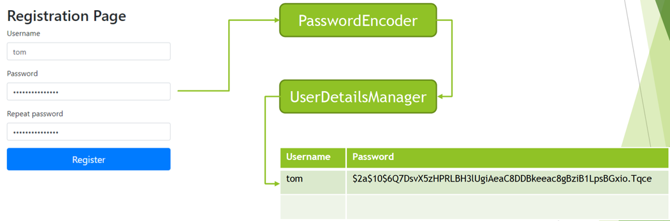

### 8.2 Password verification upon login

Upon login, provided password is encoded again and compared with one stored in database.

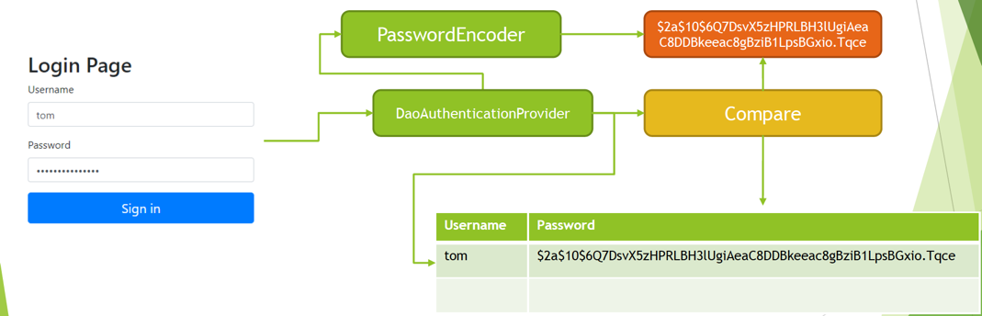

Spring Security also provides DelegatingPasswordEncoder, which uses one of the selected PasswordEncoder to encode password, and list of provided passwords decoders to verify password upon login.

DelegatingPasswordEncoder is useful as it provides flexibility and ability to easily switch between PasswordEncoders while keeping backward compatibility, for already stored hash values of passwords.

DelegatingPasswordEncoder stores hash values for password as calculated by selected PasswordEncoder with identifier stored as prefix, for example:

**{bcrypt}**$2a$10$dXJ3SW6G7P50lGmMkkmwe.20cQQubK3.HZWzG3YB1tlRy.fqvM/BG

If storage contains other algorithms used as well, for example:

**{bcrypt}**$2a$10$dXJ3SW6G7P50lGmMkkmwe.20cQQubK3.HZWzG3YB1tlRy.fqvM/BG

**{pbkdf2}**5d923b44a6d129f3ddf3e3c8d29412723dcbde72445e8ef6bf3b508fbf17fa4ed4d6b99ca763d8dc

**{sha256}**97cde38028ad898ebc02e690819fa220e88c62e0699403e94fff291cfffaf8410849f27605abcbc0

prefix is used to delegate password verification to correct PasswordEncoder.

Password salting is a security mechanism invented to protect against reversing cryptographic hash functions, with usage of a precomputed tables like Rainbow Tables.

Password Salting assumes that whenever hash for password is computed, a sequence of random bytes, known as salt is added to cleartext password before calculating hash value. This way database will not contain same hash values for the same passwords.

When password is verified, salt that is stored in clear text alongside hash value for password is used again to verify if provided password matches hash value.

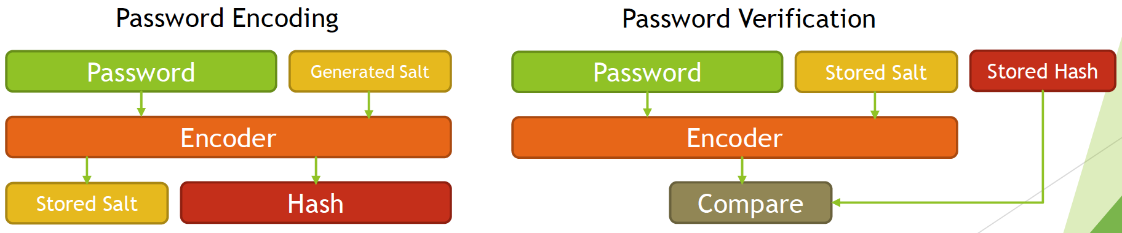

As an example, let’s look at how BCryptwill handle process of password encoding and verification:

* Password ‘secretpassword’ is encoded and stored in database as following:
* 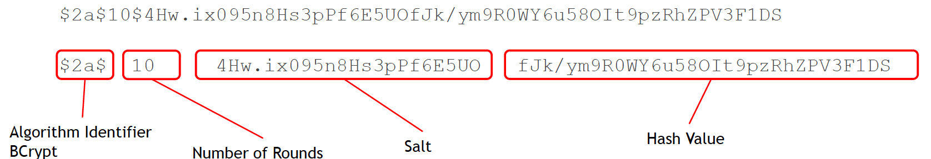
* Password ‘secretpassword’ is verified
* Raw password ‘secretpassword’ is being sent for comparison
* Stored password is retrieved as -$2a$10$4Hw.ix095n8Hs3pPf6E5UOfJk/ym9R0WY6u58OIt9pzRhZPV3F1DS
* Algorithm identified is checked -$2a$
* Number of rounds is retrieved –10
* Salt is retrieved -4Hw.ix095n8Hs3pPf6E5UO
* Hash for provided password is computed
  + Hash(‘secretpassword’, ‘4Hw.ix095n8Hs3pPf6E5UO’, 10)
* Newly generated hash is compared with stored hash

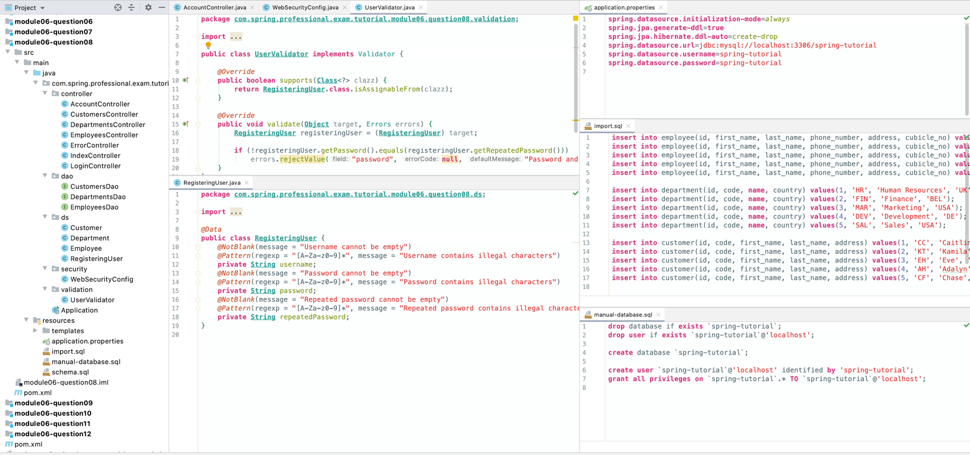

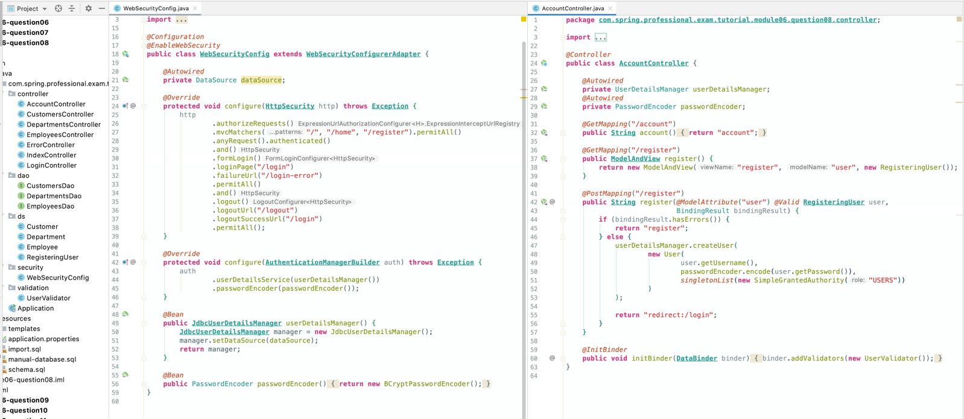

# Question 09-Why do you need method security? What type of object is typically secured at the method level (think of its purpose not its Java type).

Method level security is needed whenever more granular security rules needs to be expressed for the application. In some cases having web based rules, written based on URI patterns, might not be detailed enough, and additional set of rules needs to be applied to the application service layer of application that is being built. In that case method level security is helpful.

Method level security is typically applied at Application Service Layer.

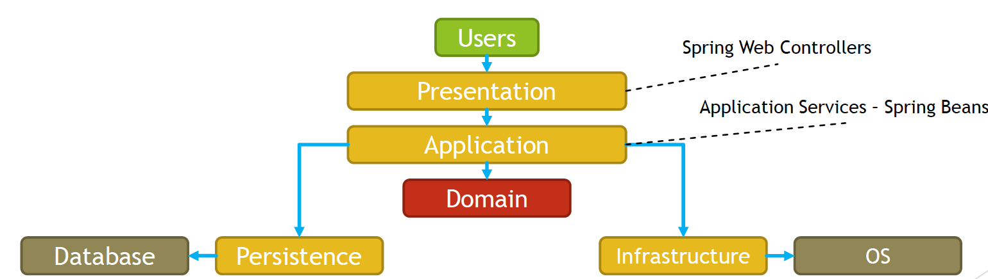

Spring supports following method level security annotations:

* @Secured
* @RolesAllowed(JSR 250)
* @PreAuthorize, @PostAuthorize, @PreFilter, @PostFilter

Annotations above will work if Method Level Security is enabled by annotation @EnableGlobalMethodSecurity, additionally you can choose which type of annotations you want to enable:

* @Secured
  + @EnableGlobalMethodSecurity(securedEnabled= true)
* @RolesAllowed
  + @EnableGlobalMethodSecurity(jsr250Enabled = true)
* @PreAuthorize, @PostAuthorize, @PreFilter, @PostFilter
  + @EnableGlobalMethodSecurity(prePostEnabled= true)

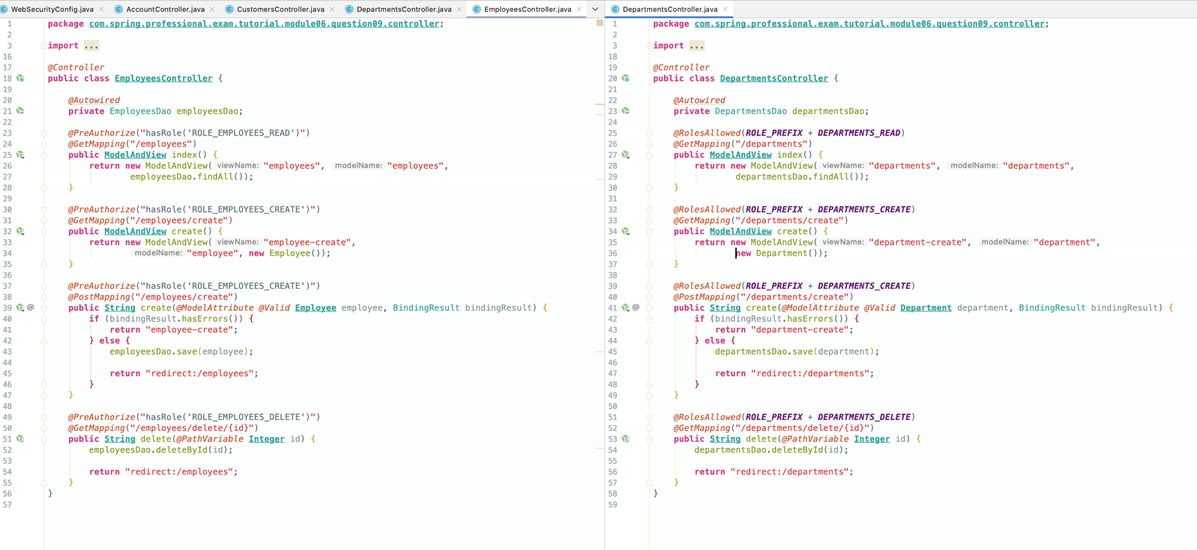

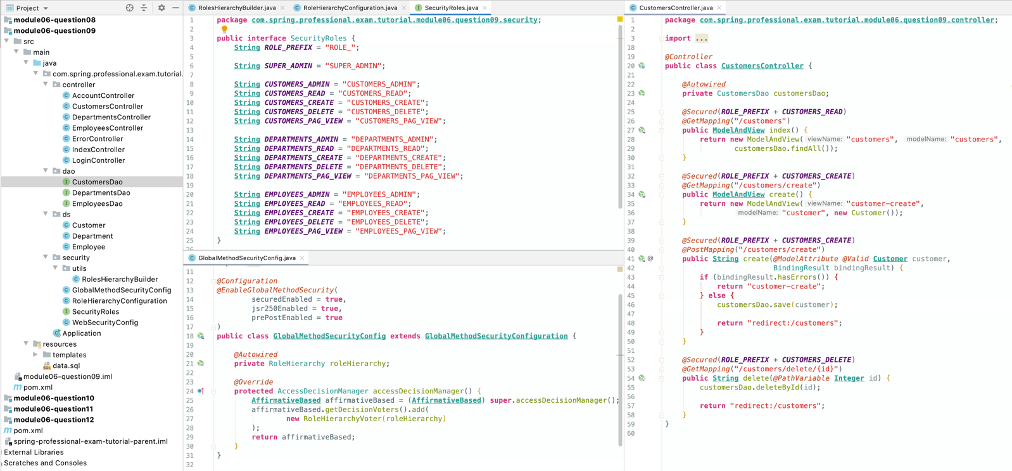

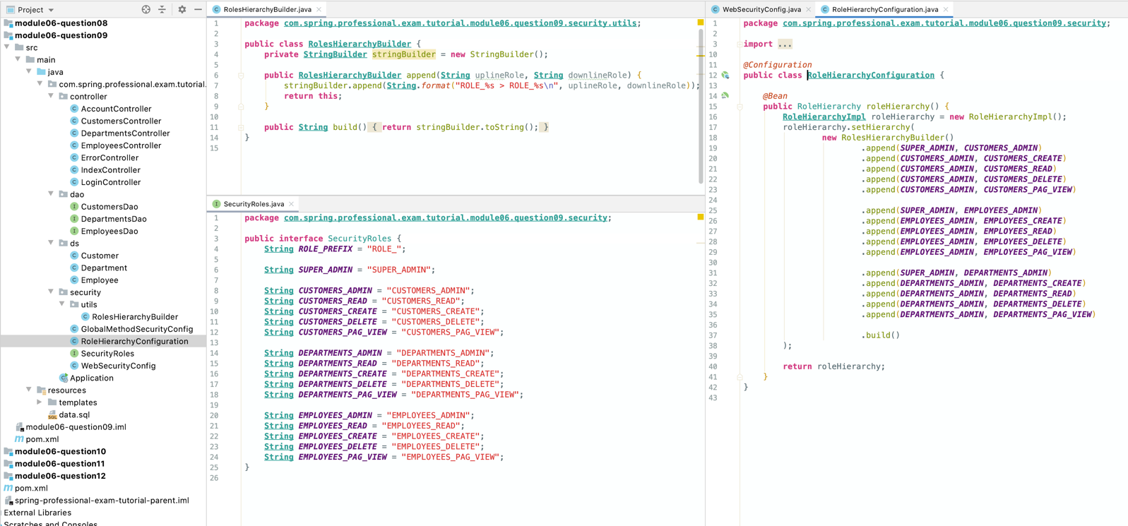

*@Configuration  
@EnableWebSecurity***public class WebSecurityConfig extends WebSecurityConfigurerAdapter** {  
  
 *@Autowired* **private** RoleHierarchy roleHierarchy;  
  
 *@Override* **protected void** configure(**HttpSecurity** http) **throws Exception** *{* http  
 .authorizeRequests()  
 .expressionHandler(expressionHandler())  
 .mvcMatchers("/", "/home").permitAll()  
 .anyRequest().authenticated()  
 .and()  
 .formLogin()  
 .loginPage("/login")  
 .failureUrl("/login-error")  
 .permitAll()  
 .and()  
 .logout()  
 .logoutUrl("/logout")  
 .logoutSuccessUrl("/login")  
 .permitAll();  
 *}  
  
 @Override* **protected void** configure(**AuthenticationManagerBuilder** auth) **throws Exception** *{* PasswordEncoder encoder = **PasswordEncoderFactories**.*createDelegatingPasswordEncoder*();  
  
 auth.inMemoryAuthentication()  
 .withUser("john")  
 .password(encoder.encode*(*"john"*)*)  
 .roles(***SUPER_ADMIN***)  
 .and()  
 .withUser("emma")  
 .password(encoder.encode*(*"emma"*)*)  
 .roles(***EMPLOYEES_ADMIN***)  
 .and()  
 .withUser("william")  
 .password(encoder.encode*(*"william"*)*)  
 .roles(***DEPARTMENTS_ADMIN***)  
 .and()  
 .withUser("lucas")  
 .password(encoder.encode*(*"lucas"*)*)  
 .roles(***CUSTOMERS_ADMIN***)  
 .and()  
 .withUser("tom")  
 .password(encoder.encode*(*"tom"*)*)  
 .roles();  
 *}* **private DefaultWebSecurityExpressionHandler** expressionHandler() *{* **DefaultWebSecurityExpressionHandler** expressionHandler = **new** DefaultWebSecurityExpressionHandler();  
 expressionHandler.setRoleHierarchy(roleHierarchy);  
 **return** expressionHandler;  
 *}*}

# Question 10-What @PreAuthorized and @RolesAllowed annotations do? What is the difference between them?

@PreAuthorized and @RolesAllowed annotations are part of Method Security Model implemented in Spring Security. Both of those annotations are evaluated before method is executed, to check if user is allowed to execute desired method.

@RolesAllowed annotation, is very similar to @Secured annotation, and both of those allows you to specify list of roles that currently authenticated user needs to have assigned to be allowed to execute guarded method. @RolesAllowed annotation is part of JSR 250 standard. Annotation is enabled by: @EnableGlobalMethodSecurity(jsr250Enabled = true)

@PreAuthorized annotation allows you to specify, conditions under which user is allowed to execute method, with usage of SpEL expressions. Expression is evaluated before method is executed. Annotation support is enabled by: @EnableGlobalMethodSecurity(prePostEnabled= true)

Difference between those annotation is that @RolesAllowed allows you to specify list of required roles, and @PreAuthorized annotation allows you to specify security rule with usage of SpEL expression.

SpEL expressions that can be used with @PreAuthorizedannotation allow for many different conditions and logic to be expressed, commonly used functions are:

* hasRole
* hasAnyRole
* hasAuthority
* hasAnyAuthority
* isAnonymous
* isAuthenticated
* isRememberMe

Example usage:



*@Controller***public class EmployeesController** {  
  
 *@Autowired* **private** EmployeesDao employeesDao;  
  
 *@GetMapping*("/employees")  
 **public ModelAndView** index() *{* **return new** ModelAndView("employees", "employees", employeesDao.findAll());  
 *}  
  
 @GetMapping*("/employees/create")  
 **public ModelAndView** create() *{* **return new** ModelAndView("employee-create", "employee", **new** Employee());  
 *}  
  
 //Can create employee test  
 @PreAuthorize*("'TEST'.equals(#employee.getFirstName()) || hasRole('ROLE_EMPLOYEES_CREATE')")  
 *@PostMapping*("/employees/create")  
 **public String** create(*@ModelAttribute @Valid* **Employee** employee, BindingResult bindingResult) *{* **if** (bindingResult.hasErrors()) *{* **return** "employee-create";  
 *}* **else** *{* employeesDao.save*(*employee*)*;  
  
 **return** "redirect:/employees";  
 *}  
 }  
  
 //can only delete employees with Ids 1 and 2  
 @PreAuthorize*("#id<=2 || hasRole('ROLE_EMPLOYEES_DELETE')")  
 *@GetMapping*("/employees/delete/{id}")  
 **public String** delete(*@PathVariable* **Integer** id) *{* employeesDao.deleteById(id);  
  
 **return** "redirect:/employees";  
 *}*}

# Question 11 -How are @PreAuthorizedand @RolesAllowedannotations implemented?



@PreAuthorizedand @RolesAllowed annotations are implemented with usage of Spring AOP and AccessDecisionVoter(s).

AccessDecisionVoter(s) are called by AccessDecisionManager, which is called by MethodSecurityInterceptor, which are registered by one of AdvisorAutoProxyCreator. Pointcuts and Advices for AOP are pointed by MethodSecurityMetadataSourceAdvisor. Currently used MethodSecurityInterceptor is pointed by GlobalMethodSecurityConfiguration#methodSecurityInterceptor.

@RolesAllowed annotation is implemented by Jsr250Voter.

@PreAuthorized annotation is implemented by PreInvocationAuthorizationAdviceVoter.

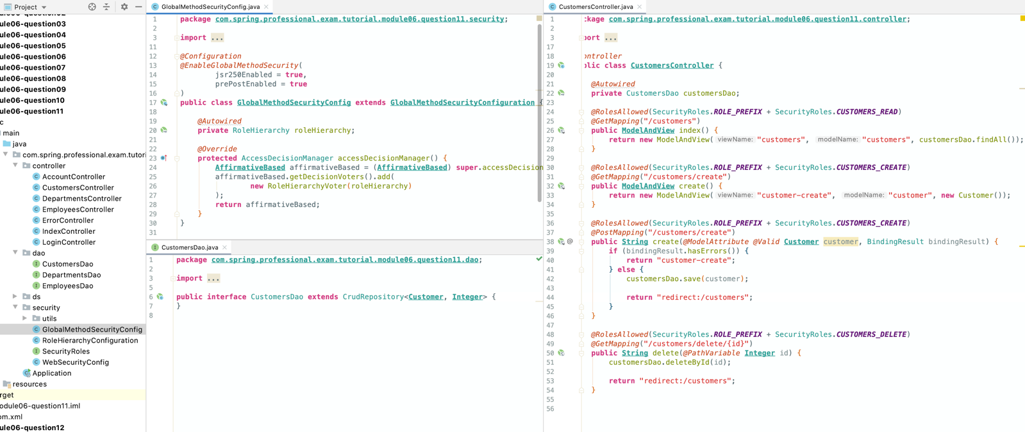

# Question 12 -In which security annotation are you allowed to use SpEL?

